RSPH L2 Award for Young Health Champions

Unit 2 Research Health Improvement Services

Learner Workbook

How to use this Learner Workbook

RSPH has developed this Learner Workbook to enable learners to provide evidence that the assessment criteria for the RSPH Level 2 Award for Young Health Champions (Unit 1 Principles of Health Improvement) have been met. Centres must ensure that the learner signs the declaration on the next page to confirm that they have read and understood the RSPH plagiarism statement.
The workbook should be signed where indicated by the Internal Assessor and Internal Verifier to confirm that the learner has met the assessment criteria and learning outcomes within this workbook. Further guidance for tutors and assessors can be obtained from the tutor guide version of this workbook.
The Learner Workbook is editable meaning that text can be inputted and saved.
Centres should refer to the RSPH External Verification Procedure before submitting assessed learner work for external verification.
The RSPH plagiarism statement, tutor guides for the workbook and External Verification Procedures can be obtained from the Centre Area of the RSPH web-site.

Learner Name
Learner Registration No.
Learner Declaration: I confirm that I have read and understood the RSPH
Plagiarism statement and that all of the accompanying work is my own.
Learner Signature
Date
Internal Assessor Comments
Please use this space to comment on whether the submitted workbook has met the assessment criteria
Internal Assessor Signature
Date

Unit 2 - Research Health Improvement Services

This Learner Workbook covers the Learning Outcomes of Unit 2: Research Health Improvement Services which is a mandatory unit.

It gives you the opportunity to research your local area to determine the health improvement services available, give details of the resources and advice available from one of them and assess the strengths and weaknesses of the area’s services as a whole.

By the end of this unit, you will know how to:

1 | Carry out a search of your local area to locate health improvement services, by being able to:
 | 1.1 Identify local services for health improvement
 | 1.2 Provide signposting to an appropriate health improvement service in your local area
 | 1.3 Identify reliable sources for health improvement
2 | Determine the resources available from a local health improvement service, by being able to:
 | 2.1 Collect information and resources relevant to a health improvement service
 | 2.2 Describe the personal advice, guidance and referral arrangements available from a health improvement service
3 | Carry out a review of a health improvement service, by being able to:
 | 3.1 Assess the strengths of local health improvement services
 | 3.2 Assess the weaknesses of local health improvement services

Learning Outcome 1: Carry out a search of the local area to locate health improvement services

  - Identify local services for health improvement

As you learned in Unit 1, individual, social and medical factors all play critical roles in protecting and improving our health and well-being.
Another important component in the promotion and protection of public health, is the range of health improvement services which we all have access to as citizens.

Task 1
Using the table provided below, write down as many health improvement services as you can think of, using the images below as a clue.
Consider the various health and wellbeing issues covered in Unit 1, and remember that these
facilities do not have to be specialist services, or even part of the NHS.

Write the relevant health issue to the service in brackets. e.g. Brook Advisory Group (Sexual Health) and state if the services are free or chargeable.

Service | Free / Chargeable

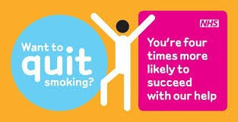

Pressures on Health Improvement Facilities

One of the biggest challenges facing the health and social care sector in the UK, is the growing number of people looking to access emergency and primary care services.

Task 2
Why do you think that more and more people are accessing primary and emergency care services?
Think about factors such as changes in our national population, the impact of media and entertainment, and the size of the NHS compared to health services in other countries.
Write your ideas in the box below and compare these with those of others in your group.

What factors did all of you or most of you agree on?

Were there any factors that only one of your group thought of?

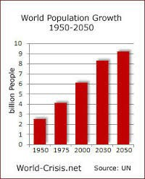

Task 3

In the table below, put a ring around the answer which you think is most accurate for each of the questions. This will test your knowledge of the impact that these factors can have on our health service.

Estimated cost of a night in hospital? | £100 | £200 |  | £500
Estimated cost of an appointment with a GP? | £15 | £25 |  | £45
Number of missed GP appointments per day? | 60,000 | 40,000 |  | 25,000
Estimated cost of obesity to the UK economy each year? | £16,000,000 |  | £16,000,000,000
Estimated cost of treating smokers to the UK economy each year? | £270,000 |  | £2,700,000,000

Referrals to Health Improvement Services

As you have learned, it is incredibly important for health and care organisations to actively work with us to help improve our own health and well-being, so that we can avoid becoming ill and relying too much on health improvement services.
You are now going to take on the role of a Discharge Coordinator working in a busy Accident and Emergency department.
You are about to encounter five different patients, all of whom originally reported to A+E as a direct or indirect result of one of the health and well-being issues covered in Unit 1.
As part of the Making Every Contact Count (MECC) initiative, your job is to give them guidance and support by suggesting both changes they could make to their behaviour and health improvement services they could make use of, in order to avoid the situation re-occurring.

Patient 1
Ben is 12 years old and has been brought to hospital from school with acute chest pains. He loves football, but since he broke his leg in a nasty tackle a year ago, he hasn't done any exercise. His older brother is now in year 12 and is allowed off site for lunch. Ben likes this as he gets his brother to bring back chips for him.

Patient 2
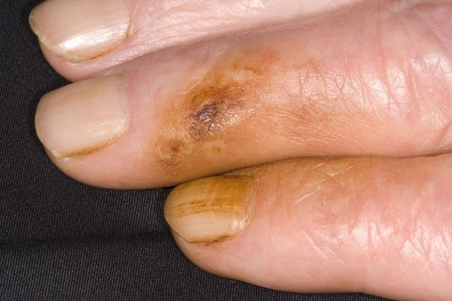
Drew is a fourteen-year-old male, who was rushed to A+E after seeming to have suffered a possible asthma attack at school, despite not being diagnosed with the condition.
He is very quiet and shy when you try and talk to him, especially when his mum is in the room. You notice that he has yellow stains around the end of his fingers.

Patient 3
Lucy is a seventeen-year-old girl, who has been brought to your department with severe cuts to her wrists.
A teacher accompanied Lucy in the ambulance from school, as they are currently finding it difficult to contact her parents.
The teacher tells you that Lucy’s grades have recently deteriorated and that she has seemed to be very withdrawn and downbeat around school.

Referrals to Health Improvement Services

Patient 4
Ali is a twenty-five-year-old male and has reported to A+E after beginning to experience excruciating pain and loss of blood from his penis.
Ali is generally fit and healthy and works out at the gym every couple of nights. He has never touched a cigarette and very rarely drinks alcohol, but did have a bit too much to drink a couple of weekends ago.
He becomes a little shy when you try to ask him more questions about this particular weekend.

Patient 5
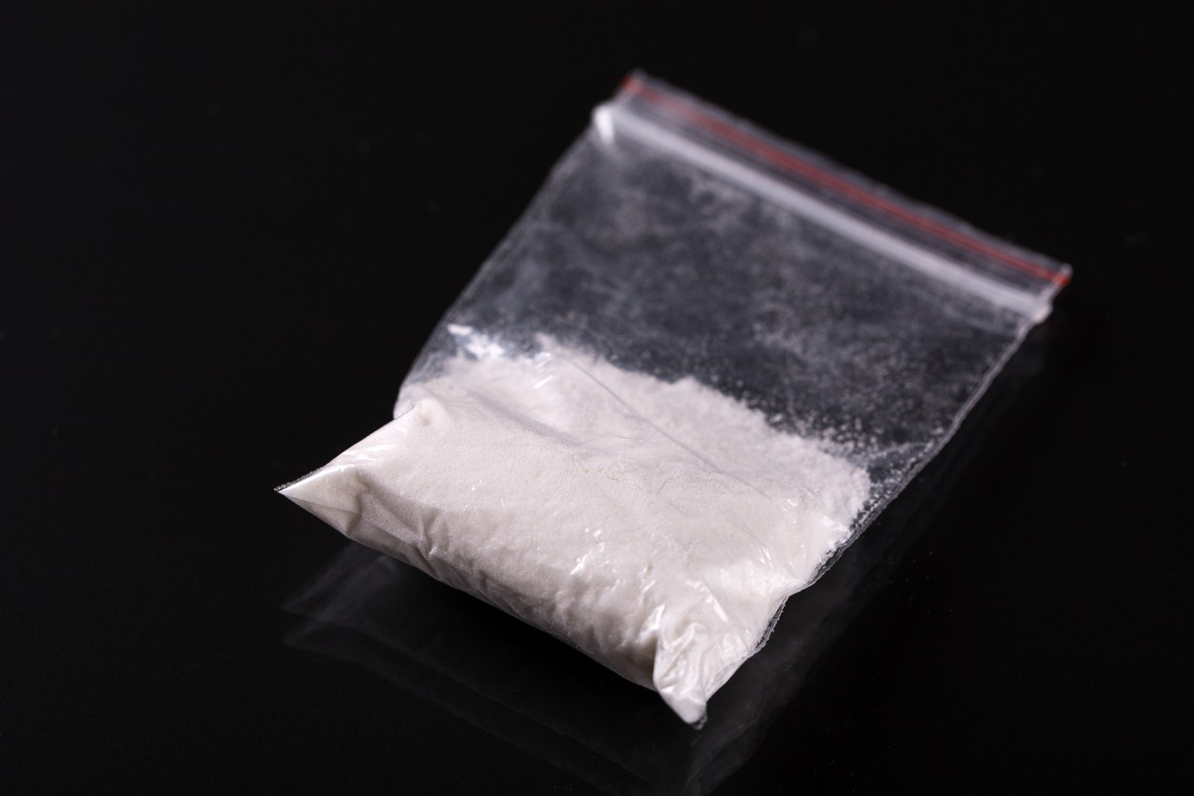
Melissa is a twenty-two year old female, who has been brought to the hospital by ambulance from a nightclub in the city centre, having suffered a sudden cardiac arrest.
She is a recent graduate and just started working in the City of London in banking. Her patient records show her to have a clean bill of health until now. When she regains consciousness, she tells you that she exercises every day and regularly runs half-marathons.
However, the paramedic who brought her into the hospital tells you that when they were removing her clothes to use the defibrillator, a little packet of white powder fell on the floor.

1.2 Provide signposting to an appropriate health improvement service in your local area

Task 4

Before you provide follow-up care for each of the patients listed above, you need to spend some time coming up with a health improvement plan for each of them and provide them with information about the health improvement service(s) you have suggested they could make use of. Using the table provided on the next page you need to:

- Give the name and address of the service you have identified in your local area

- Select which patients you are going to refer to each service. You can refer your patient to more than one if you feel that this would be appropriate.

- Identify the transport links and directions, distance and any eligibility or registration requirements for each health improvement service

- Briefly describe any problems you can foresee with the patient accessing the service. This can include things like problems with disabled access, restricted opening hours or whether the service is free or chargeable.

Service | Patient(s) | Name & address of service | Directions/transport | Eligibility/registration?  Access issues? Free/chargeable?
Reducing alcohol, tobacco or drug con- sumption
Increasing physical activity
Promoting a healthy weight
Sexual health
Mental health and emotional support

1.3 Identify reliable sources of information for health improvement

Task 5
Where would you obtain reliable sources of information for health improvement services? Give THREE examples of a reliable source of information, then give one example of an unreliable source, explaining why it is unreliable (a reliable source is one which is regularly kept up-to- date and provided by an official authority).

Reliable sources of information

An unreliable source of information

Reason why this source is unreliable

Assessment Decision and Feedback
Internal Assessor
Assessment Criterion 1.1 |  | Met | Not met
Assessment Criterion 1.2 |  | Met | Not met
Assessment Criterion 1.3 |  | Met | Not met
Comments / feedback
Learning Outcome Achieved |  | YES | NO
Name | Signature | Date

Learning Outcome 2: Determine the resources available from a local health improvement service

Before you formally refer each patient to the health improvement facility which you have decided is suited to them, you need to research the resources available at each facility which will have a positive impact on that individual's health.
This is an important step in both making sure you have made the right decision, as well as in convincing your patient that the referral you are making will have a positive impact upon their health and well-being.

2.1 Collect information and resources relevant to a health improvement service

2.2 Describe the personal advice, guidance and referral arrangements available from a health improvement service

Task 6
You need to collect information from a local health improvement service and determine what resources are available from the service. Use the table on the next page to outline the information that you have collected and what you have found out about the resources available.
This information can be included on leaflets and other information that you have collected from the centre, or information downloaded from the service’s website.
Resources could include exercise equipment, weighing scales, sources of fresh fruit and vegetable, free condoms or smoking cessation aids like Nicorette.
To meet the assessment criteria, you only need to provide information on ONE service.

Task 7
Again, use the table on the next page to outline the type of advice, guidance and referral services available at the service you identified for Task 6. This advice and guidance could be in the form of specialist counselling or signposting to more specialist help.

Service | Information and Resources | Advice, Guidance and Referral  arrangements

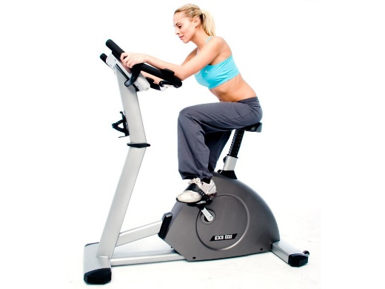
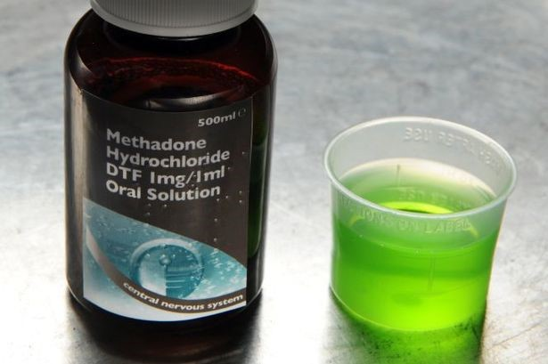

Assessment Decision and Feedback
Internal Assessor
Assessment Criterion 2.1 |  | Met | Not met
Assessment Criterion 2.2 |  | Met | Not met
Comments / feedback
Learning Outcome Achieved |  | YES | NO
Name | Signature | Date

Learning Outcome 3: Carry out a review of a local health improvement service

Suitability of Health Improvement Resources

The constantly changing risks to our individual and public health mean that the health improvement services available to us also need to be flexible and suited to our needs.
This means that the government, local councils and the NHS need to ensure that individuals are able to access the resources and guidance they need, in order to protect and improve their health.

3.1 Assess the strengths of local health improvement services

3.2 Assess the weaknesses of local health improvement services

Task 8
The Consultant who is currently supervising your work has asked you to review the suitability of the health improvement facilities to which you have referred your patients.
The Clinical Commissioning Group operating in the local area have been given some funding, which they plan to use to make improvements to the resources and guidance available at one health improvement facility in your local area.
Thinking about the health and wellbeing needs of the local area, consider the health improvement services as a whole that you have referred patients too. Assess:

Two strengths of the service which the funding could make even better.
Two weaknesses of the service which the funding could address and improve.

Assessment Decision and Feedback
Internal Assessor
Assessment Criterion 3.1 |  | Met | Not met
Assessment Criterion 3.2 |  | Met | Not met
Comments / feedback
Learning Outcome Achieved |  | YES | NO
Name | Signature | Date

Internal Verifier declaration

Internal Verifier

I have internally verified this assessment workbook and agree with the assessment decisions.
Signed: Name: Date:

