RSPH Level 2 Award for Young Health Champions
(Unit 6 Encouraging a Healthy Weight and Healthy Eating)

RSPH Level 2 Award in Encouraging a Healthy Weight and Healthy Eating

Learner Workbook
How to use this Learner Workbook

RSPH has developed this Learner Workbook to enable learners to provide evidence that the assessment criteria for the RSPH Level 2 Award for Young Health Champions (Unit 6 Encouraging a Healthy Weight and Healthy Eating) and the RSPH Level 2 Award in 6 Encouraging a Healthy Weight and Healthy Eating have been met. Centres must ensure that the learner signs the declaration on the next page to confirm that they have read and understood the RSPH plagiarism statement.
The workbook should be signed where indicated by the Internal Assessor and Internal Verifier to confirm that the learner has met the assessment criteria and learning outcomes within this workbook. Further guidance for tutors and assessors can be obtained from the tutor guide version of this workbook.
The Learner Workbook is editable meaning that text can be inputted and saved.
Centres should refer to the RSPH External Verification Procedure before submitting assessed learner work for external verification.
The RSPH plagiarism statement, tutor guides for the workbook and External Verification Procedures can be obtained from the Centre Area of the RSPH web-site.

Learner Name Learner Registration No.
Learner Declaration: I confirm that I have read and understood the RSPH Plagiarism statement and that all of the accompanying work is my own work. I have identified any relevant sources of information that I have used in supporting my responses this workbook and these are cited within.
Learner Signature Date

Internal Assessor Comments
Please use this space to comment on whether the submitted workbook has met the assessment criteria.

Internal Assessor Signature Date

Learning Outcome 1: Understand factors that result in people being under or over a healthy weight.

  - Describe THREE social factors that could result in people being under or over a healthy weight
  - Outline THREE factors that are individual – specific which could result in a person being under or over a healthy weight

Task 1

You are provided with three case studies by your tutor. For EACH case study a) outline ONE social factor and b) describe ONE individual factor that can result in the person in the case study being overweight or underweight.

Case study Name | Social Factor | Individual factor

Assessment Decision and Feedback
Internal Assessor
Assessment Criterion 1.1 |  | Met | Not met
Assessment Criterion 1.2 |  | Met | Not met
Comments / feedback
Learning Outcome Achieved |  | YES | NO
Name | Signature | Date

Learning Outcome 2: Understand the personal consequences of being under or over a healthy weight

2.1 Outline the direct effect on physical health of being under or over weight
2.2 Outline the effect on mental health and emotional well-being of being under or over a
healthy weight.

Task 2
Using the case studies provided for Task 1; outline the direct effect on the physical and mental health and emotional well-being of being overweight or underweight for each individual in the case study

Case Study Name | Effect on physical health | Effect on mental health and emotional well-being

Assessment Decision and Feedback
Internal Assessor
Assessment Criterion 2.1 |  | Met | Not met
Assessment Criterion 2.2 |  | Met | Not met
Comments / feedback
Learning Outcome Achieved |  | YES | NO
Name | Signature | Date

Learning Outcome 3: Understand the principle of healthy eating
3.1 State what constitutes a healthy diet

Task 3 The figure below represents the Eatwell Guide. Label each section with the types of food which it should contain and give TWO examples of each.
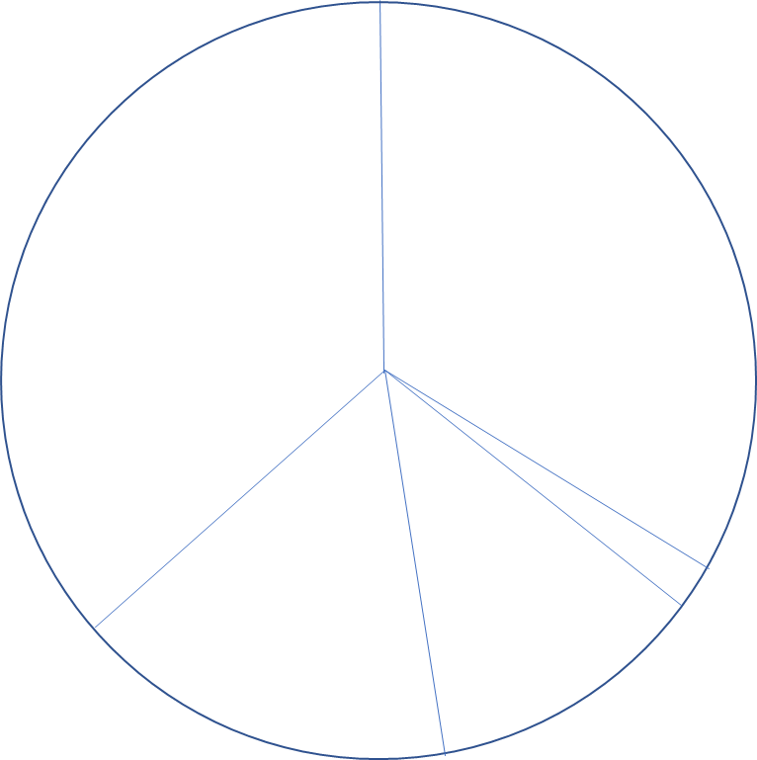

Task 4
Circle the correct answer to the following statements.

- Most people in the UK need to eat more / less saturated fat.

- Most people in the UK need to eat more / less fruit and vegetables.

- Most people in the UK need to eat more / less fibre.

- Most people in the UK need to eat more / less salt.

- Most people in the UK need to eat more / less starchy food.

- Most people in the UK need to eat more / less sugar.

3.2 Identify good sources of protein, carbohydrates, fats, essential vitamins and minerals
Task 5
From the list below, identify the foods which are good sources of the nutrients in the table and write their names in the space provided. You should select TWO foods from the list for each nutrient. Each food may be used more than once or not at all.
Mackerel  (without bones) |  | Red Meat |  | Walnuts
Canned vegetables |  | Chicken |  | Frozen fruit
Lentils |  | Kidney Beans |  | Whole (unskimmed) Milk
Oily fish  (with bones) |  | Green leafy vegetables |  | Brown Rice
Liver |  | Wholemeal bread |  | Dried fruit

Nutrient | Good food source for nutrient
Protein
Unsaturated fats
Vitamins and minerals
Iron
Calcium
Fibre
Carbohydrate

3.3 Outline THREE positive and THREE negative effects of diet on health
Task 6
In the table below, outline three effects of diet on a person’s health.
Positive Effects of a good diet | Negative effects of a poor diet
Example: Having a well-balanced diet can improve energy levels. | Example: Eating too much salt which can increase the risk of high blood pressure.
1.

2.

3.

3.4 State how food labels can support healthy eating

Task 7: In order to maintain a healthy weight, we need to balance what we eat with what we need. Read the scenario below and answer the following questions to help your friend to understand food labelling
You go with a friend to the shops. Your friend wants to lose weight and generally improve their health. They say they always tend to buy the same foods which they think are the healthier options. While shopping with them, you see they pick food off the shelf without looking at the contents or comparing it with alternatives. When you say this to them they reply they wouldn’t know what to look for.
If the nutrients listed on the food label are colour coded Red, Amber or Green, which foods with this type of coding should they try to include more of and which foods should they try to limit in their shopping basket?
E.g. should they include more food with red codes or less food?
More of | Less of

A number of terms are commonly found on food labels. Explain the meaning of each of the terms shown in the table below
Label | Meaning
Use by (date)

Best before (date)

Light or lite

Low fat

No added sugar or unsweetened

If your friend is choosing a ready meal with a nutritional label, they should compare the nutritional information listed below. For each piece of nutritional information listed, state its importance for healthy eating.

Key label information | Why it is important to compare
Fats

Sugars

Salt

Saturates

Fibre

Assessment Decision and Feedback
Internal Assessor
Assessment Criterion 3.1 |  | Met | Not met
Assessment Criterion 3.2 |  | Met | Not met
Assessment Criterion 3.3 |  | Met | Not met
Assessment Criterion 3.4 |  | Met | Not met
Comments / feedback
Learning Outcome Achieved |  | YES | NO
Name | Signature | Date

Learning Outcome 4: Know how to provide help and support to the individual
4.1 List THREE agencies / organisations which provide services for individuals wishing to
manage their weight and eat more healthily and outline the services provided.

Task 8
Two friends have come to see you; one has asked if you can help them to lose weight and the other to eat more healthily. You suggest to them that there are many services and agencies around that can support them to achieve a healthy weight and eat healthily and they will need to find one that suits their individual needs best.

In the table below, list the agencies you think can support your friends and explain why, by stating the services they provide.

State agency or organisation name (these can be local or national) | State what services they provide and how this could help your friends
1.

2.

3.

4.2 Describe THREE ways by which an individual could be encouraged to achieve a healthy weight and eat more healthily.

Task 9: Your tutor will provide you with four case studies. Using one case study describe (in the table below) THREE practical ways by which the individual could be encouraged to manage their weight and eat more healthily.

Name of case study:

1.

2.

3.

4.3 Identify THREE barriers to changing behaviour with regard to weight management and healthy eating and how these can be overcome.
Task 10: Choose a different case study from the one you used in Task 9. In the boxes below please state THREE barriers to changing behaviour and suggest how these could be overcome.
Barrier | How the barrier could be overcome
1.

2.

3.

Assessment Decision and Feedback
Internal Assessor
Assessment Criterion 4.1 |  | Met | Not met
Assessment Criterion 4.2 |  | Met | Not met
Assessment Criterion 4.3 |  | Met | Not met
Comments / feedback
Learning Outcome Achieved |  | YES | NO
Name | Signature | Date

Internal Verifier declaration

Internal Verifier

I have internally verified this assessment workbook and agree with the assessment decisions.

Signed:

Name:

Date:

