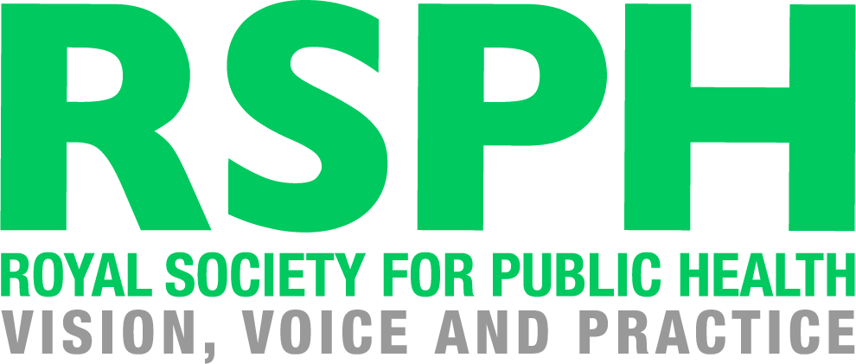

RSPH L2 Award for Young Health Champions

Unit 1 Principles of Health Improvement

RSPH Level 1 Award in Health Improvement

Learner Assessment Workbook

How to use this Learner Workbook

RSPH has developed this Learner Workbook to enable learners to provide evidence that the assessment criteria for the RSPH Level 2 Award for Young Health Champions (Unit 1 Principles of Health Improvement) or the RSPH Level 1 Award in Health Improvement have been met. Centres must ensure that the learner signs the declaration on the next page to confirm that they have read and understood the RSPH plagiarism statement.
The workbook should be signed where indicated by the Internal Assessor and Internal Verifier to confirm that the learner has met the assessment criteria and learning outcomes within this workbook. Further guidance for tutors and assessors can be obtained from the tutor guide version of this workbook.
The Learner Workbook is editable meaning that text can be inputted and saved.
Centres should refer to the RSPH External Verification Procedure before submitting assessed learner work for external verification.
The RSPH plagiarism statement, tutor guides for the workbook and External Verification Procedures can be obtained from the Centre Area of the RSPH web-site.

Learner Name Learner Registration No.

Learner Declaration: I confirm that I have read and understood the RSPH Plagiarism statement and that all of the accompanying work is my own.

Learner Signature Date
Internal Assessor Comments

Please use this space to comment on whether the submitted workbook has met the assessment criteria

Internal Assessor Signature Date

Unit 1 - Principles of Health Improvement

In this unit, you will learn about how we define health and wellbeing, the ways in which our health and wellbeing can be affected by both our own decisions and society around us, and how we can all improve our own health.

By the end of this unit, you will:

1 | Understand what is meant by health and wellbeing, by being able to
 | 1.1 State the WHO definition of health
 | 1.2 State what is significant about this definition
2 | Understand factors that have led to the improvement of public health, by being able to:
 | 2.1 Understand three public health advances that have resulted in large scale improvements in public health
 | 2.2 Explain how each of these advances has had an impact on the public's health
3 | Understand how lifestyle may have a negative effect on health, by being able to:
 | 3.1 Identify three long term health conditions that are linked to lifestyle behaviours
 | 3.2 List three reasons why people make unhealthy lifestyles choices
4 | Understand how lifestyle may have a positive effect on health, by being able to:
 | 4.1 Identify three behaviours that have a positive effect on health
 | 4.2 State how these behaviours have a positive effect on the individual
 | 4.3 List three reasons why people make healthy lifestyle choices
5 | Know how to improve your own health, by being able to:
 | 5.1 Determine your own attitude to health
 | 5.2 Identify a lifestyle change that can improve your health
 | 5.3 Describe how you could achieve this lifestyle change
 | 5.4 Identify the benefits of this change
 | 5.5 Identify who or what can help you with this change

Learning Outcome 1: Understand what is meant by health and wellbeing

  - State the WHO definition of health
  - State what is significant about this definition

In order to understand how we can improve our own health and well-being, it is important that we know how to define both terms.

Task 1
Using the bubble provided below, write down as many words and terms as you can think of, which you feel relate to health and well-being. Does anyone in your group have different ideas to you?

Health and Wellbeing

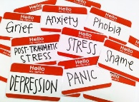

What do you think your answers say about your approach to health and wellbeing?

Task 2

In small groups, research and consider the cases of the well-known figures below. Do any of these cases change your understanding of health and wellbeing?

- Zoella and her ‘digital detoxes’
- Demi Lovato and her struggles with addiction
- Michael Carrick and the impact of the 2009 Champions League Final
- Prince Harry and the loss of his mum

In order to understand how we can improve our own health and well-being, it is important that we know how to define both terms.

Task 3
As you have learned from Task 2, it is not always easy to define health and wellbeing. We all have many different types of health and they can often be at very different and fast-changing levels at any one time.
As Young Health Champions, you will work with the definition of health put forward by the World Health Organisation (WHO).

What is the WHO definition of health?

What is significant about this definition?

Assessment Decision and Feedback
Internal Assessor
Assessment Criterion 1.1 |  | Met | Not met
Assessment Criterion 1.2 |  | Met | Not met
Comments / feedback
Learning Outcome Achieved |  | YES | NO
Name | Signature | Date

Learning Outcome 2: Understand factors that have led to the
improvement of public health

  - Identify three public health advances that have resulted in large scale improvements in public health
  - Explain how these advances have had an impact on the public’s health
Over the last century, our public health has been protected and improved by a number of developments across both medicine and society.

Task 4
Below are a number of different advances which each had a large scale impact on public health.

- The discovery of antibiotics in 1928
https://www.healio.com/endocrinology/news/print/endocrine-today/%7B15afd2a1-2084-4ca6-a4e6-7185f5c4cfb0%7D/penicillin-an-accidental-discovery-changed-the-course-of-medicine
- The introduction of the NHS cervical screening programme in 1988
https://www.gov.uk/government/publications/health-matters-making-cervical-screening-more-accessible/health-matters-making-cervical-screening-more-accessible--2
- The introduction of the smoking ban in pubs in 2007
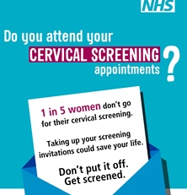
https://www.bbc.co.uk/news/health-40444460
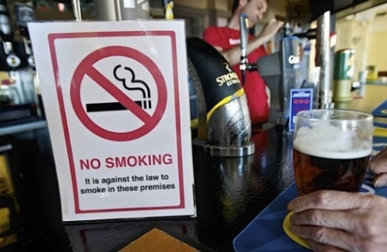

Using the case studies above, or choosing some of your own, complete the table below to show how they have positively impacted upon the public’s health. Other topics could include the provision of clean drinking water, better housing or the creation of the NHS.

Health Advance | How has it improved the public’s health?
1.
2.
3.

Assessment Decision and Feedback
Internal Assessor
Assessment Criterion 2.1 |  | Met | Not met
Assessment Criterion 2.2 |  | Met | Not met
Comments / feedback
Learning Outcome Achieved |  | YES | NO
Name | Signature | Date

Learning Outcome 3: Understand how lifestyle may have a negative
effect on health

3.1 Identify three long term health conditions that are linked to lifestyle behaviours

Whilst the public health advances have been key factors in the improvement of our health and wellbeing over the years, the way in which we choose to behave is just as important.

Task 5
In a group, research and discuss lifestyle choices which can have a negative impact upon health.
Negative impact

e.g. smoking

Then, using your research, what are THREE long-term conditions that could develop if such lifestyle choices are sustained over a period of time? Write these down using the table below.

Lifestyle Choice | Long-term Condition
Example – Smoking | Lung cancer

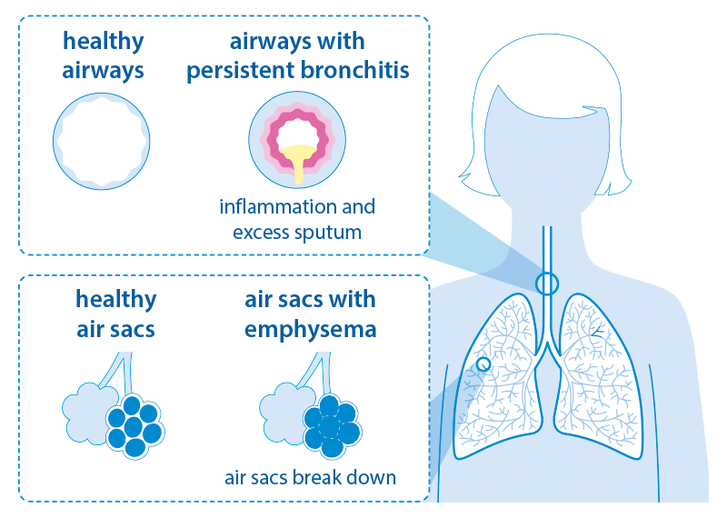
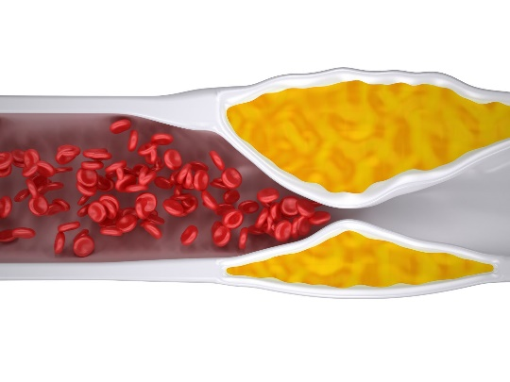
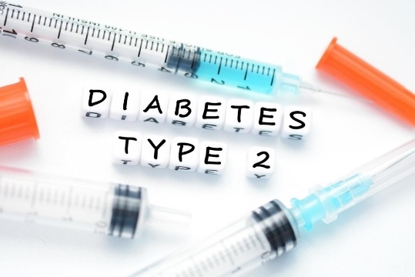

3.2 List three reasons why people make unhealthy lifestyle choices

Task 6
Read the case study below or use one given to you by your tutor.

Leigh is 16 and taking her GCSEs this year. She generally finds school a bit of a struggle but is desperate to get the grades she needs to continue her plan to be a midwife.

Leigh spends three or four hours a day on social media, mainly to see what her friends are doing and to follow celebrities she looks up to.

Her Leavers’ Prom is only a few months away and she has been feeling negatively about her body and comparing herself against photos of her friends on social media. She has recently found herself making excuses to miss mealtimes at home.

- Discuss the issues which may be affecting the individual's health hinted at by the case study.

- Discuss the causes or factors that are encouraging the individual to act the way they are doing.

- In the table below THREE reasons why people make unhealthy lifestyle choices.
1.

2.

3.

Assessment Decision and Feedback
Internal Assessor
Assessment Criterion 1 |  | Met | Not met
Assessment Criterion 2 |  | Met | Not met
Comments / feedback
Learning Outcome Achieved |  | YES | NO
Name | Signature | Date

Learning Outcome 4: Understand how lifestyle may have a
positive effect on health

4.1 Identify three behaviours that have a positive effect on health
4.2 State how these behaviours have a positive impact on the individual

As well as having a negative impact upon our health and well-being, our individual behaviour can also have a positive impact.

Task 7

In a group, research and write down THREE lifestyle choices that can have a positive impact upon health.

Positive impact

Regular exercise

e.g. regular exercise

Then, using your research, what are THREE long-term benefits that could develop if such lifestyle choices are sustained over a period of time? Write these down using the table below.

Lifestyle Choice | Long-term Benefit
Example – regular exercise | Easier to maintain a healthy weight

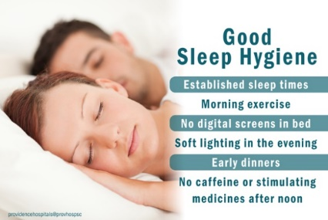

4.3 List three reasons why people make healthy lifestyle choices

Task 8

Look at the case study below or another one provided by your tutor
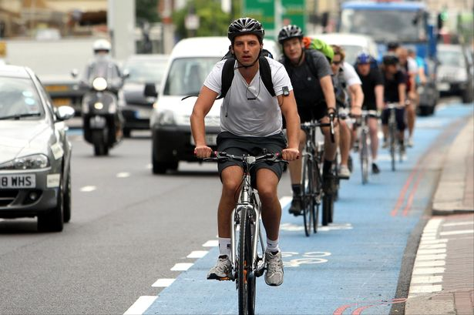
Adam is 18 and works an apprentice for Wigan Borough Council. He used to regularly play football when he was at school but has struggled to keep playing since his friends all went in different directions after leaving school.
After noticing that he was little out of breath walking up the stairs at work, he decided to buy a bike after a suggestion from his work colleague. They both live quite close to each other, so have started cycling into work together in a morning.
Adam has noticed that his ride in is much harder work if he doesn’t have a proper breakfast.

  - Discuss the issues hinted at by the case study which may be affecting the individual's health.

  - Discuss the causes or factors that are encouraging the individual to act the way they do.

  - Write in the table below THREE reasons why the individual has made lifestyle choices that are healthy and will benefit their health.
1.

2.

3.

Assessment Decision and Feedback
Internal Assessor
Assessment Criterion 4.1 |  | Met | Not met
Assessment Criterion 4.2 |  | Met | Not met
Assessment Criterion 4.3 |  | Met | Not met
Comments / feedback
Learning Outcome Achieved |  | YES | NO
Name | Signature | Date

Learning Outcome 5: Know how to improve your own health

5.1 Determine own attitude to health

Task 9

Your tutor will provide you with a health and wellbeing survey. Complete this survey (it should take about ten minutes) in order to further explore your own attitude to health.

Once the survey has been completed, discuss your answers with your peers and tutor.

Are there any other words you would now health and wellbeing, compared to when you started the course?

Health and wellbeing

Has completing this unit and taking the health and wellbeing survey revealed anything to you about your own attitude to health?

This could be something that you regularly do that you hadn’t realised was good for your health, or something that you would like to change to improve your wellbeing.

5.2 Identify a lifestyle change that can improve your health

5.3 Describe how you could achieve this lifestyle change

5.4 Identify the benefits of this change

5.5 Identify who or what can help you to achieve your aim.

Task 10

Reflecting on what you have learned in this module, use the grid below to suggest one change you could make to your own lifestyle, which you feel would be of benefit to your health and wellbeing.
What do you want to do differently or more of? Be specific about this. Number of times, by a certain date, increase or reduce an amount.

How will you know you have achieved? Can you measure if you are achieving it?

Think about whether it is achievable for you. Is it a change YOU want to make? Do you need to make the change bigger or smaller

Is this change relevant to you? How much do you want to achieve it? Will it make a positive impact on your life?

How long are you going to give yourself? Do you need to plan in time to reflect?

How will I achieve this? What resources will I need? Will I need anyone’s support?

Think of a nice reward for yourself if you carry it out successfully

Assessment Decision and Feedback
Internal Assessor
Assessment Criterion 5.1 |  | Met | Not met
Assessment Criterion 5.2 |  | Met | Not met
Assessment Criterion 5.3 |  | Met | Not met
Assessment Criterion 5.4 |  | Met | Not met
Assessment Criterion 5.5 |  | Met | Not met
Comments / feedback
Learning Outcome Achieved |  | YES | NO
Name | Signature | Date

Internal Verifier declaration

Internal Verifier

I have internally verified this assessment workbook and agree with the assessment decisions.
Signed: Name: Date:

