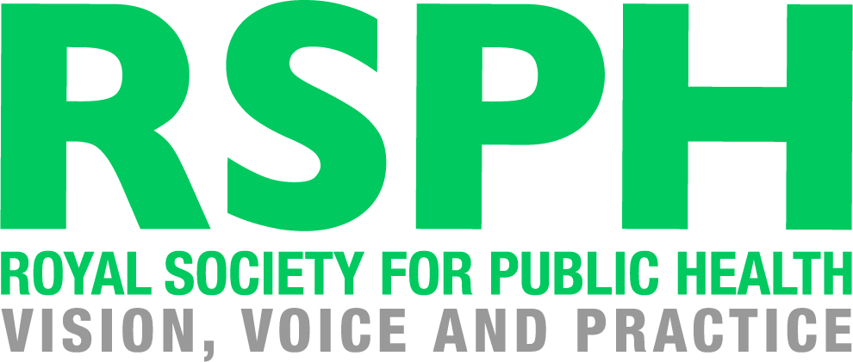

RSPH L2 Award for Young Health Champions:

Unit 3 Deliver a Health Improvement Message

Learner Workbook

How to use this Learner Workbook

RSPH has developed this Learner Workbook to enable learners to provide evidence that the assessment criteria for the RSPH Level 2 Award for Young Health Champions (Unit 3 Deliver a Health Improvement Message) have been met. Centres must ensure that the learner signs the declaration on the next page to confirm that they have read and understood the RSPH plagiarism statement.
The workbook should be signed where indicated by the Internal Assessor and Internal Verifier to confirm that the learner has met the assessment criteria and learning outcomes within this workbook. Further guidance for tutors and assessors can be obtained from the tutor guide version of this workbook.
The Learner Workbook is editable meaning that text can be inputted and saved.
Centres should refer to the RSPH External Verification Procedure before submitting assessed learner work for external verification.
The RSPH plagiarism statement, tutor guides for the workbook and External Verification Procedures can be obtained from the Centre Area of the RSPH web-site.

Learner Name Learner Registration No.

Learner Declaration: I confirm that I have read and understood the RSPH Plagiarism statement and that all of the accompanying work is my own.

Learner Signature Date
Internal Assessor Comments

Please use this space to comment on whether the submitted workbook has met the assessment criteria

Internal Assessor Signature Date

Unit 3 - Deliver a Health Improvement Message

This Learner Workbook covers the outcomes of Unit 3: Deliver a Health Improvement Message of the RSPH Level 2 Young Health Champions Qualification.

In this unit, you will prepare and deliver a health improvement message of your choice to either another individual or a group of peers and then reflect on how successful you think your presentation was and how well it was received.

By the end of this unit, you will be able to:

1 | Understand why peer advice is important for the delivery of health improvement messages, by being able to:
 | 1.1 Outline the advantages and disadvantages of providing advice to peers
 | 1.2 Compare peer advice with advice from ‘authority’ figures.
2 | Carry out preparations for delivering a health improvement message, by being able to:
 | 2.1 Identify the key points of the health improvement message
 | 2.2 Obtain resources relevant to the chosen health improvement message and audience
 | 2.3 Prepare materials suitable for the health improvement message.
3 | Deliver a health improvement message, by being able to:
 | 3.1 Explain the role of the Young Health Champion
 | 3.2 Present a positive message using language appropriate to the topic and audience
 | 3.3 Use a style of delivery appropriate for the topic and audience
 | 3.4 Use listening skills and respond appropriately to questions
 | 3.5 Signpost opportunities to health improvement services.
4 | Carry out a review of the delivery of the health improvement message, by being able to:
 | 4.1 Assess the strengths of the delivery of the health improvement message
 | 4.2 Assess what could be improved in the delivery of the health improvement message.

Learning Outcome 1: Understand why peer advice is important for the delivery of health improvement messages

1.1 Outline the advantages and disadvantages of providing advice to peers

As you learned in Unit 2, professionals and organisations play a key role in providing expert support and guidance to those currently experiencing negative health outcomes.
Another crucial source of advice in the promotion and preservation of public health, is that provided by our peers, friends and family.

Task 1
Select one of the five individuals you met in Unit 2, during your time working as a Discharge Coordinator in Accident and Emergency (you will have to refer back to your unit 2 Learner Workbook for this). Based on your understanding of what a "peer" means, write down your definition of "peer" below. Then choose ONE of the individuals and discuss in groups what their "peers" might be like. State which case study you have chosen below and record your thoughts on the likely characteristics of their peers.
For the specific case of the individual you have selected, consider the advice they could have been provided with by their peers. What do you think would be the benefits and drawbacks of peer advice? Use the table below to record your views.

Definition of "peer group" | Case study peer's characteristics
Advantages of peer advice | Disadvantages of peer advice

1.2 Compare peer advice with advice from ‘authority’ figures

Task 2

Think about 'authority' figures that you encounter such as teachers, nurses or parents - What gives them their authority? Compare peer advice with advice from authority figures and consider the benefits and drawbacks of each - use the text box below to record your views.

Consider issues such as confidentiality, familiarity, impartiality, experience, expertise and authority.

strengths of peer advice strengths of "authority" advice
weaknesses of peer advice | weaknesses of "authority" advice

Assessment Decision and Feedback
Internal Assessor
Assessment Criterion 1.1 |  | Met | Not met
Assessment Criterion 1.2 |  | Met | Not met
Comments / feedback
Learning Outcome Achieved |  | YES | NO
Name | Signature | Date

Learning Outcome 2: Carry out preparations for delivering a health improvement message

Task 3

When delivering a health message to another individual, you have a very small window in which to make a potentially huge impact upon the rest of their life. This makes your preparation prior to delivery absolutely crucial.

The first step in preparing your heath improvement message is deciding what it is you are going to focus on.

This could be something which you see as a problem in your school, your local area or an issue which you feel is of national importance.

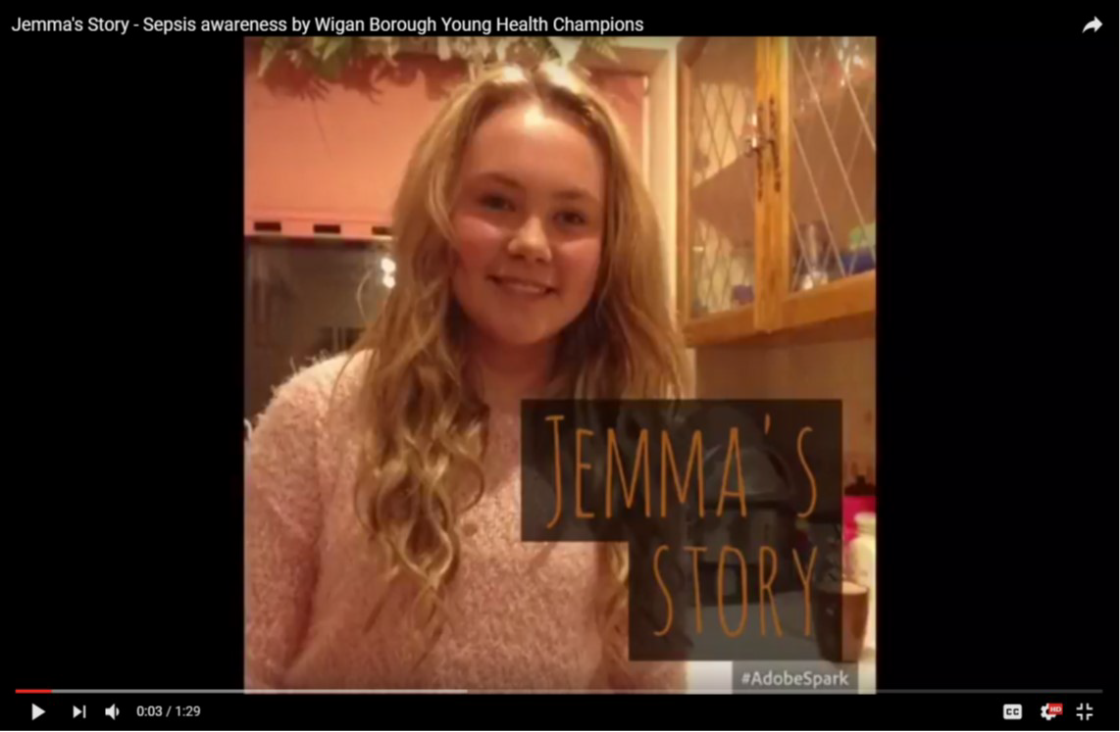
Example 1

A group of Young Health Champions at Wigan Council created a poster and video campaign to raise awareness of the signs and symptoms of Toxic Shock Syndrome, Sepsis and Meningitis. This topic was chosen as one of the group had sadly lost his sister to Toxic Shock Syndrome.
The video has been shared across social media platforms and has been viewed over a 1000 times.
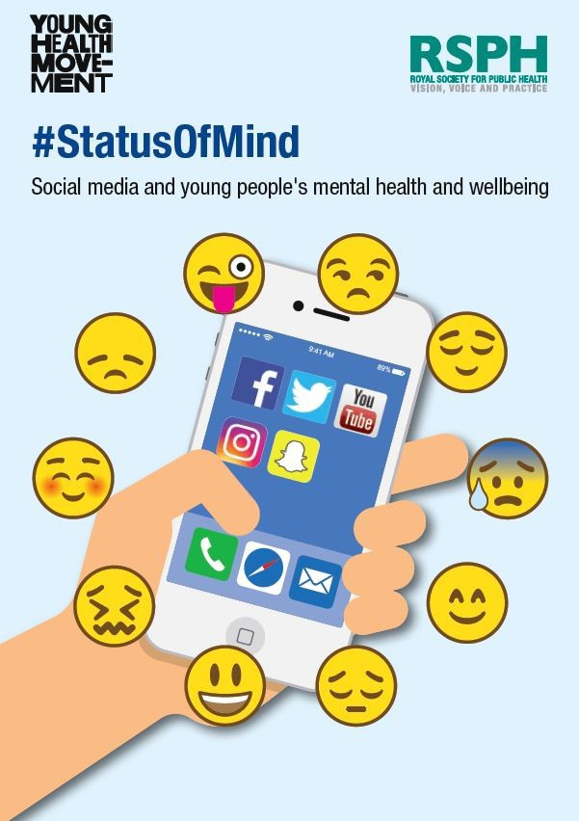

Example 2

You could carry out a survey or another form of engagement in your local setting to identify a health and wellbeing issue which you feel is particularly relevant.
For example, you may identify an ongoing concern about cyberbullying which you don’t feel is being adequately publicised or addressed.
You could then use these concerns to promote safe use of social media in your local area, and signpost those affected by cyberbullying to available online support services.

In order to help guide which specific health improvement topic you will look to address, you may choose to refer to other sources of information which are available to the public.
For example, this could be from the Joint Strategic Needs Assessment for your local area (easy to find on a search engine) or by entering your postcode onto the Public Health Profiles section of the Public Health England website—https://fingertips.phe.org.uk/profile/health- profiles.

2.1 Identify the key points of the health improvement message

2.2 Obtain resources relevant to the chosen health improvement message and audience

2.3 Prepare materials suitable for the health improvement message

Task 4
Once you have decided on your choice of health improvement topic, you will need to provide some structure and content to your message.

Use the prompts below to plan the key parts of your health improvement message. Then write this up using the table on the next page. You should think about:

The key points of your health improvement message:

You will need to divide your health improvement message into a number of key points that you want to get across to your audience. These could include:

- The key behaviours that affect your health improvement topic and which may have a positive or negative effect on health improvement.

- Is there a specific behaviour which has a major effect and should be addressed as a priority?

- How can individuals be motivated to change behaviours which may be affecting their health and wellbeing?

- What are the short and long-term effects of these behaviours upon the individual’s health and well- being?

- What are the short and long-term effects of these behaviours upon wider society?

- Where can you signpost the individual to for more help if needed?

Obtaining resources relevant to your health improvement message and audience

What resources do you need to be able to get your health improvement message across to your audience? Where can you obtain these resources?

Preparing materials suitable for the health improvement message

What materials do you need to prepare in order to deliver your health improvement message?

Reasons for choosing the health improvement topic

Key points of the health improvement message

Resources required and where you might obtain these from

Materials prepared

(You will need to hand these in with your completed workbook as part of your assessment evidence)

Assessment Decision and Feedback
Internal Assessor
Assessment Criterion 2.1 |  | Met | Not met
Assessment Criterion 2.2 |  | Met | Not met
Assessment Criterion 2.3 |  | Met | Not met
Comments / feedback
Learning Outcome Achieved |  | YES | NO
Name | Signature | Date

Learning Outcome 3: Deliver a health improvement message

3.1 Explain the role of the Young Health Champion
3.2 Present a positive message using language appropriate to the topic and audience
3.3 Use a style of delivery appropriate for the topic and audience
3.4 Use listening skills and respond appropriately to questions
3.5 Signpost opportunities to health improvement service

Task 5

Now that you have prepared your health improvement message, you will need to deliver it to your chosen audience. But before doing so it is advisable that you practice what you are going to say and how you are going to say it.

Role of the Young Health Champion:

As part of your presentation you will need to inform your audience of what a Young Health Champion (YHC) does and, equally important, what the YHC cannot do. The YHC can tell their audience what the Government health recommendations are that are relevant to the health improvement topic, where additional information can be found and where an individual can obtain support to improve their health. The YHC is not a subject expert and cannot provide medical advice.

Use of language:

The language that you use in your presentation should be appropriate to the audience and the topic of the health improvement message; and the health improvement message should be presented in a positive way.

Style of delivery:

You should try to vary the style and pace of your delivery. This should also be appropriate to the topic as well as your audience.

Listening skills:

Your audience will want to ask you questions during or after your presentation. You will need to respond to these questions in an appropriate manner and, when responding to questions use this as an opportunity to signpost to health improvement services or give more detailed information as appropriate.

Signpost opportunities:

This is arguably the most important part of your health improvement message; where can members of your audience obtain further information and support if required?

Make sure that you do practice your presentation in advance, ideally to a friend or colleague who can comment on how you sound and if you are speaking too fast or too slow etc. Try to maintain eye contact with your audience. You don’t have to learn your message off by heart so you can use notes during your presentation to help you, but make sure that you don’t just read out your notes to your audience.

Your tutor will be assessing you for this part of the unit and will be scoring you against all of the points 3.1 – 3.5 listed above.

Assessment Decision and Feedback
Internal Assessor
Assessment Criterion 3.1 |  | Met | Not met
Assessment Criterion 3.2 |  | Met | Not met
Assessment Criterion 3.3 |  | Met | Not met
Assessment Criterion 3.4 |  | Met | Not met
Assessment Criterion 3.5 |  | Met | Not met
Comments / feedback
Learning Outcome Achieved |  | YES | NO
Name | Signature | Date

NB: The tutor will need to attach their assessment of the learner for the delivery of the health improvement message to this workbook. A form is available for the tutor’s use for this from the centre area of the RSPH web-site.

Learning Outcome 4: Carry out a review of the delivery of the health improvement message

4.1 Assess the strengths of the delivery of the health improvement message

4.2 Assess what could be improved in the delivery of the health improvement message

Now that you have delivered your health improvement message you will need to find out how effective it was and if you need to do anything differently next time.
There are two essential elements to this; getting feedback and deciding what you want to change.

Task 6
Complete the grid below with feedback from THREE different sources:

⇒ A fellow Young Health Champion
⇒ A member of the audience
⇒ Your Young Health Champion Coordinator

Elements of your health improvement message and presentation that these should consider include content, pitch, structure, interaction with the audience, ability to answer questions and effectiveness of signposting. They should also advise you on how you might improve your presentation and health improvement message next time.

Person feeding back and title | Positive elements | How can I improve it next time?
YHC
Audiencemember
YHC
tutor/ mentor

Task 7

Use the boxes below to provide a summary of how you thought your presentation went, what you might change next time, the questions that you were asked and how you used your presentation to provide signposting about your health improvement topic.
How do you feel your presentation went? Refer back to the feedback you have been given earlier in the exercise.

What questions were you asked, how did you answer and what signposting did you recommend?

Assessment Decision and Feedback
Internal Assessor
Assessment Criterion 4.1 |  | Met | Not met
Assessment Criterion 4.2 |  | Met | Not met
Comments / feedback
Learning Outcome Achieved |  | YES | NO
Name | Signature | Date

Internal Verifier declaration

Internal Verifier

I have internally verified this assessment workbook and agree with the assessment decisions.
Signed: Name: Date:

