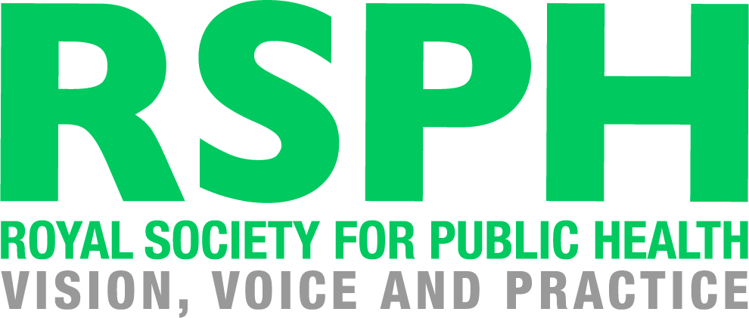

RSPH L2 Award for Young Health Champions

Unit 1 Principles of Health Improvement

RSPH Level 1 Award in Health Improvement

Learner Assessment Workbook

How to use this Learner Workbook

RSPH has developed this Learner Workbook to enable learners to provide evidence that the assessment criteria for the RSPH Level 2 Award for Young Health Champions (Unit 1 Principles of Health Improvement) or the RSPH Level 1 Award in Health Improvement have been met. Centres must ensure that the learner signs the declaration on the next page to confirm that they have read and understood the RSPH plagiarism statement.
The workbook should be signed where indicated by the Internal Assessor and Internal Verifier to confirm that the learner has met the assessment criteria and learning outcomes within this workbook. Further guidance for tutors and assessors can be obtained from the tutor guide version of this workbook.
The Learner Workbook is editable meaning that text can be inputted and saved.
Centres should refer to the RSPH External Verification Procedure before submitting assessed learner work for external verification.
The RSPH plagiarism statement, tutor guides for the workbook and External Verification Procedures can be obtained from the Centre Area of the RSPH web-site.

Learner Name Learner Registration No.

Learner Declaration: I confirm that I have read and understood the RSPH Plagiarism statement and that all of the accompanying work is my own.

Learner Signature Date
Internal Assessor Comments

Please use this space to comment on whether the submitted workbook has met the assessment criteria

Internal Assessor Signature Date

Unit 1 - Principles of Health Improvement

In this unit, you will learn about how we define health and wellbeing, the ways in which our health and wellbeing can be affected by both our own decisions and society around us, and how we can all improve our own health.

By the end of this unit, you will:

1 | Understand what is meant by health and wellbeing, by being able to
 | 1.1 State the WHO definition of health
 | 1.2 State what is significant about this definition
2 | Understand factors that have led to the improvement of public health, by being able to:
 | 2.1 Understand three public health advances that have resulted in large scale improvements in public health
 | 2.2 Explain how each of these advances has had an impact on the public's health
3 | Understand how lifestyle may have a negative effect on health, by being able to:
 | 3.1 Identify three long term health conditions that are linked to lifestyle behaviours
 | 3.2 List three reasons why people make unhealthy lifestyles choices
4 | Understand how lifestyle may have a positive effect on health, by being able to:
 | 4.1 Identify three behaviours that have a positive effect on health
 | 4.2 State how these behaviours have a positive effect on the individual
 | 4.3 List three reasons why people make healthy lifestyle choices
5 | Know how to improve your own health, by being able to:
 | 5.1 Determine your own attitude to health
 | 5.2 Identify a lifestyle change that can improve your health
 | 5.3 Describe how you could achieve this lifestyle change
 | 5.4 Identify the benefits of this change
 | 5.5 Identify who or what can help you with this change

Learning Outcome 1: Understand what is meant by health and wellbeing

  - State the WHO definition of health
  - State what is significant about this definition

In order to understand how we can improve our own health and well-being, it is important that we know how to define both terms.

Task 1
Using the bubble provided below, write down as many words and terms as you can think of, which you feel relate to health and well-being. Does anyone in your group have different ideas to you?

Health and Wellbeing

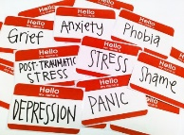

What do you think your answers say about your approach to health and wellbeing?

Task 2

In small groups, research and consider the two cases below of the footballer Fabrice Muamba and the singer Amy Winehouse. How do these cases support your understanding of health and wellbeing? (you will need to understand the background in each case so make sure you research them). Enter your answers in the box below.

In order to understand how we can improve our own health and well-being, it is important that we know how to define both terms.

Task 3
As you have learned from previous activities, the concept of health is not an easy or simple one to define. As Young Health Champions, you will work with the definition of health put forward by the World Health Organisation (WHO).

What is the WHO definition of health?

What is significant about this definition?

Assessment Decision and Feedback
Internal Assessor
Assessment Criterion 1.1 |  | Met | Not met
Assessment Criterion 1.2 |  | Met | Not met
Comments / feedback
Learning Outcome Achieved |  | YES | NO
Name | Signature | Date

Learning Outcome 2: Understand factors that have led to the
improvement of public health

2.1 Identify THREE public health advances that have resulted in large scale improvements in public health
2.2 Explain how each of these advances has had an impact on the public’s health
Over the last century, our public health has been protected and improved by a number of developments across both medicine and society.

Task 4
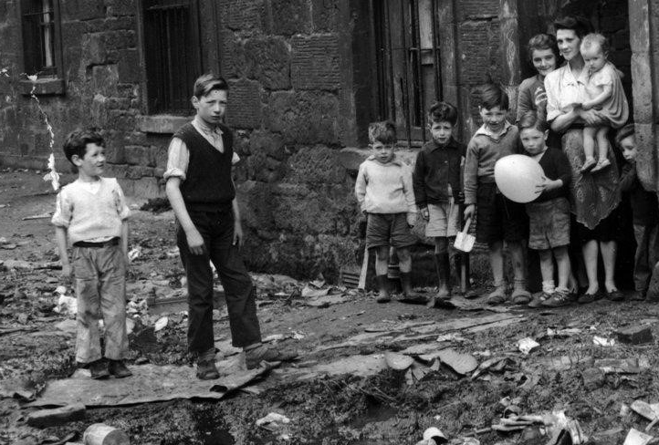
Consider the images below, which represent a number of different advances in public health and which
had a large scale impact.
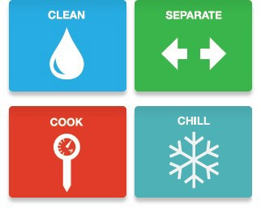
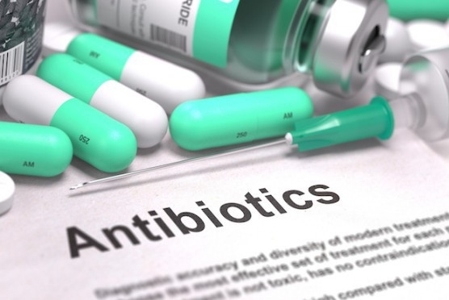

Pick out three of the above advances, or choose some of your own after researching the topic or discussing
it with your peers. Then complete the table below to show how they have positively impacted upon the
public’s health.

Health Advance | How has it improved the public’s health?
1.
2.
3.

Assessment Decision and Feedback
Internal Assessor
Assessment Criterion 2.1 |  | Met | Not met
Assessment Criterion 2.2 |  | Met | Not met
Comments / feedback
Learning Outcome Achieved |  | YES | NO
Name | Signature | Date

Learning Outcome 3: Understand how lifestyle may have a negative
effect on health

3.1 Identify THREE long term health conditions that are linked to lifestyle behaviours

Whilst the public health advances have been key factors in the improvement of our health and wellbeing over the years, the way in which we choose to behave is just as important.

Task 5
In a group, research and discuss lifestyle choices which can have a negative impact upon health. Then, using your research, what are THREE long term conditions that could develop if such lifestyle choices are sustained over a period of time? Write these down in the table below.
For example, someone who smokes could develop asthma.

Lifestyle Choice | Long term condition

3.2 List THREE reasons why people make unhealthy lifestyle choices
Task 6
Read the case study below or use one given to you by your tutor. Then:

- Discuss the issues which may be affecting the individual's health hinted at by the case study.
- Discuss the causes or factors that are encouraging the individual to act the way they do.
- Write in the table below THREE reasons why people make unhealthy lifestyle choices.

Leigh aged 16

Leigh is 16 and taking her GCSEs this year. She finds school a bit of a struggle but is working really hard towards her exams.
Recently, she has started to miss a few meals as she wants to look good in her dress for the Year 11 prom at the end of term. Leigh spends a LOT of time on social media, uploading photos
and sharing her thoughts on the world.

Assessment Decision and Feedback
Internal Assessor
Assessment Criterion 1 |  | Met | Not met
Assessment Criterion 2 |  | Met | Not met
Comments / feedback
Learning Outcome Achieved |  | YES | NO
Name | Signature | Date

Learning Outcome 4: Understand how lifestyle may have a
positive effect on health

4.1 Identify THREE behaviours that have a positive effect on health

4.2 State how these behaviours have a positive effect on the individual

As well as having a negative impact upon our health and well-being, our individual behaviour can also have a positive impact.

Task 7
In small groups, discuss ways in which individuals can act which would have a positive impact on their health. After you have finished your discussions write down three of these behaviours in the table below:

For each of the behaviours that you have listed, state how the behaviour has a positive effect on the individual.

4.3 List THREE reasons why people make healthy lifestyle choices

Task 8

Look at the case study below or another one provided by your tutor. Then:
  - Discuss the issues hinted at by the case study which may be affecting the individual's health.
  - Discuss the causes or factors that are encouraging the individual to act the way they do.
  - Write in the table below THREE reasons why the individual has made lifestyle choices that are healthy and will benefit their health.

Himesh, 17
Himesh is 17 and works part-time at the Caledonian Cafe. Some of his wages go towards rent and food for the rest of the family. He helps out at home, cooking and looking after his younger brothers who are 5 and 9 because his Mum is out working a lot. He decided at new year to give up soft drinks for water.

Assessment Decision and Feedback
Internal Assessor
Assessment Criterion 4.1 |  | Met | Not met
Assessment Criterion 4.2 |  | Met | Not met
Assessment Criterion 4.3 |  | Met | Not met
Comments / feedback
Learning Outcome Achieved |  | YES | NO
Name | Signature | Date

Learning Outcome 5: Know how to improve your own health

5.1 Determine own attitude to health

Task 9
Your tutor will provide you with a health and wellbeing survey. Complete this survey (it should take about ten minutes) in order to further explore your own attitude to health.

Once the survey has been completed, discuss your answers with your peers and tutor. Has your understanding of health and wellbeing changed from when you started this course?

What does the survey reveal about your thoughts on health? Use the table below to consider this.

Diet? | Current level of health and wellbeing?
Physical activity? | Need to improve your health and wellbeing?

5.2 Identify a lifestyle change that can improve your health.
5.3 Describe how you could achieve this lifestyle change
5.4 Identify the benefits of this change
5.5 Identify who or what can help you to achieve your aim.

Within this unit, you have developed your understanding of health and wellbeing, as well as the ways in which it can be both be improved and damaged by our individual choices and other factors in wider society.

Task 10
Reflecting on this learning, use the grid below to suggest one change you could make to your own lifestyle, which you feel would be of benefit to your health and wellbeing.
This reflection will allow you to begin to consider what you might focus on as part of your health promotion campaign in Unit 3.

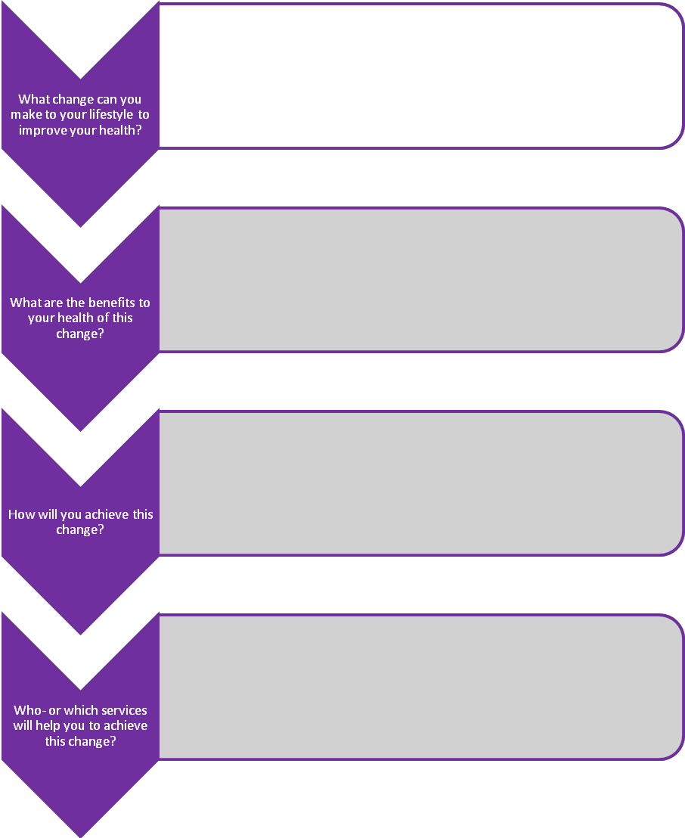

Assessment Decision and Feedback
Internal Assessor
Assessment Criterion 5.1 |  | Met | Not met
Assessment Criterion 5.2 |  | Met | Not met
Assessment Criterion 5.3 |  | Met | Not met
Assessment Criterion 5.4 |  | Met | Not met
Assessment Criterion 5.5 |  | Met | Not met
Comments / feedback
Learning Outcome Achieved |  | YES | NO
Name | Signature | Date

Internal Verifier declaration

Internal Verifier

I have internally verified this assessment workbook and agree with the assessment decisions.
Signed: Name: Date:

